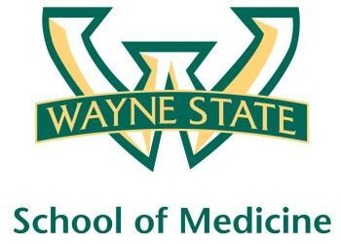
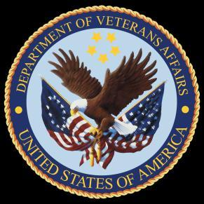
Wayne State University - VA Medical Center
Department of Internal Medicine

August 5, 2015 – September 1, 2015
12:00 pm – 1:00 pm
Room C3800

Monday | Tuesday |  | Wednesday | Thursday | Friday
08/03 | 08/04 |  | 08/05  Orientation by CMR  (12pm- 1pm) | 08/06  Jeopardy/  MKSAP Questions | 08/07  No Morning Report
08/10  Hepatitis Lecture by  Dr. Antaki | 08/11  Orientation by NP Megan Irwin Part I |  | 08/12  Orientation by Megan Irwin  Part II | 08/13  Red Team  Short Case 1 | 08/14  Green Team  Short Case 1
08/17  Radiology Lecture by  Dr. Alam | 08/18  Nephrology Lecture by  Dr. Abu-Hamdan |  | 08/19  Blue Team  Short Case 1 | 08/20  Yellow Team  Short Case 1 | 08/21  Red Team  Short Case 2
08/24  Radiology Lecture by  Dr. Alam | 08/25  Green Team  Short Case 2 |  | 08/26  Blue Team  Short Case 2 | 08/27  Yellow Team  Short Case 2 | 08/28  Palliative Care  Lecture by  Dr. Stellini
08/31  Care of the Psychiatrically Ill Patient |  | 09/01  M and M Morning Report

