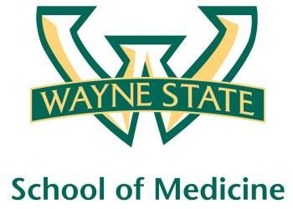
Wayne State University - VA Medical Center
Department of Internal Medicine

September 30th, 2015 – October 27, 2015
12:00 pm – 1:00 pm
Except Monday 1:15 pm – 2:15 pm
Room A3102

Monday | Tuesday |  | Wednesday | Thursday | Friday
09/28 | 09/29 |  | 09/30  Orientation by CMR  (12pm- 1pm) | 10/01  Orientation by NP Megan Irwin Part I | 10/02  Orientation by Megan Irwin  Part II
10/05  Radiology Lecture I  1:15 pm to 2:15 pm | 10/06  Nephrology Lecture  Dr. Abu- Hamdan |  | 10/07  Academic Half Day  No Morning Report | 10/08  Red Team  Short Case 1 | 10/09  Green Team  Short Case 1
10/12  Radiology Lecture II  1:15 pm to 2:15 pm | 10/13  Blue Team  Short Case 1 |  | 10/14  Academic Half Day  No Morning Report | 10/15  Yellow Team  Short Case 1 | 10/16  Palliative Lecture Dr. Stellini
10/19  Red Team  Short Case  2  1:15 pm to 2:15 pm | 10/20  Green Team  Short Case 2 |  | 10/21  Academic Half Day  No Morning Report | 10/22  Blue Team  Short Case 2 | 10/23  Care of the Psychiatrically Ill Patient
10/26  Yellow Team  Short Case 2  1:15 pm to 2:15 pm |  | 10/27  M and M morning report Case

