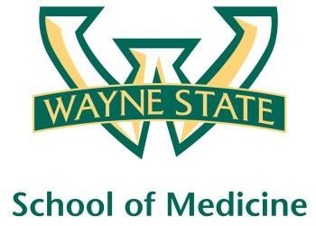
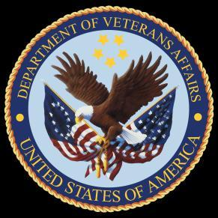
Wayne State University - VA Medical Center
Department of Internal Medicine

October 28th, 2015 –November 24th, 2015
12:00 pm – 1:00 pm
Except Monday 1:15 pm – 2:15 pm
Room A3102

Monday | Tuesday |  | Wednesday | Thursday | Friday
10/26 | 10/27 |  | 10/28  Orientation by CMR  (12pm- 1pm) | 10/29  Orientation by NP Megan Irwin Part I | 10/30  Orientation by Megan Irwin  Part II
11/02  Radiology Lecture I  1:15 pm to 2:15 pm | 11/03  Nephrology Lecture  Dr. Abu- Hamdan |  | 11/04  Academic Half Day  No Morning Report | 11/05  Red Team  Short Case 1 | 11/06  Green Team  Short Case 1
11/09  Radiology Lecture I  1:15 pm to 2:15 pm | 11/10  Cardiology Lecture  Dr. Ramappa |  | 11/11  Academic Half Day  No Morning Report | 11/12  Blue Team  Short Case 1 | 11/13  Palliative Lecture Dr. Stellini
11/16  Yellow Team  Short Case 1  1:15 pm to 2:15 pm | 11/17  Red Team  Short Case  2 |  | 11/18  Academic Half Day  No Morning Report | 11/19  Green Team  Short Case 2 | 11/20  Blue Team  Short Case 2
11/23  Yellow Team  Short Case 2  1:15 pm to 2:15 pm |  | 11/24  M and M morning report Case

