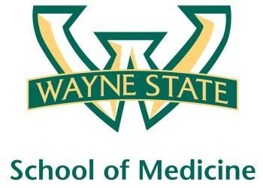
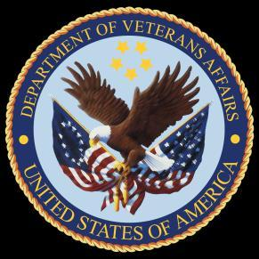
Wayne State University - VA Medical Center
Department of Internal Medicine

November 25th-December 22nd, 2015
12:00 pm – 1:00 pm
Except Monday 1:15 pm – 2:15 pm
Room A3102

Monday | Tuesday |  | Wednesday | Thursday | Friday
11/23 | 11/24 |  | 11/25  Orientation by CMR  (12pm- 1pm) | 11/26 | 11/27  Orientation by Megan Irwin  Part I
11/30  Orientation by Megan Irwin  Part II  1:15 pm to 2:15 pm | 12/01  Red Team  Short Case 1 |  | 12/02  Academic Half Day  No Morning Report | 12/03  Green Team  Short Case 1 | 12/04  Blue Team  Short Case 1
12/07  Radiology Lecture  1:15 pm to 2:15 pm | 12/08  Cardiology Lecture  Dr. Ramappa |  | 12/09  Academic Half Day  No Morning Report | 12/10  Acid Base Lecture  Dr. Mohanty | 12/11  Yellow Team  Short Case 1
12/14  Red Team  Short Case  2  1:15 pm to 2:15 pm | 12/15  Green Team  Short Case 2 |  | 12/16  Academic Half Day  No Morning Report | 12/17  Blue Team  Short Case 2 | 12/18  Yellow Team  Short Case 2
12/21  Palliative Lecture Dr. Stellini  1:15 pm to 2:15 pm |  | 12/22  M and M morning report Case

