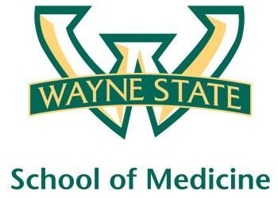
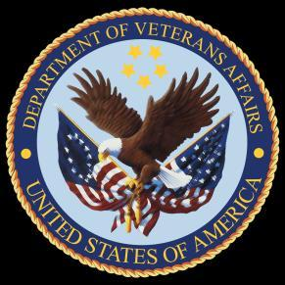
Wayne State University - VA Medical Center
Department of Internal Medicine

December 23rd- January 19th 2015
12:00 pm – 1:00 pm
Except Monday 1:15 pm – 2:15 pm
Room A3102

Monday | Tuesday |  | Wednesday | Thursday | Friday
12/21 | 12/22 |  | 12/23  Orientation by CMR  (12pm- 1pm) | 12/24  No Morning Report | 12/25
12/28  NP Orientation by Megan Irwin  1:15 pm to 2:15 pm | 12/29  Red Team  Short Case 1 |  | 12/30  Academic Half Day  No Morning Report | 12/31  Green Team  Short Case 1 | 01/01
01/04  Blue Team  Short Case 1  1:15 pm to 2:15 pm | 01/05  Yellow Team  Short Case 1 |  | 01/06  Academic Half Day  No Morning Report | 01/07  Red Team  Short Case  2 | 01/08  Nephrology Lecture by  Dr. Abu-Hamdan
01/11  Radiology Lecture  1:15 pm to 2:15 pm | 01/12  Green Team  Short Case 2 |  | 01/13  Academic Half Day  No Morning Report | 01/14  Blue Team  Short Case 2 | 01/15  Palliative Lecture Dr. Stellini
01/18  MLK Holiday |  | 12/22  Yellow Team  Short Case 2

Mandatory Code Grey Simulation Schedule for Block 7

Will be held at A2 ICU Simulation Room from 1pm-2pm with Dr. Lee

Team schedule as follows

1/8/2016 Green and Yellow Team

1/15/2016 Red and Blue Team

