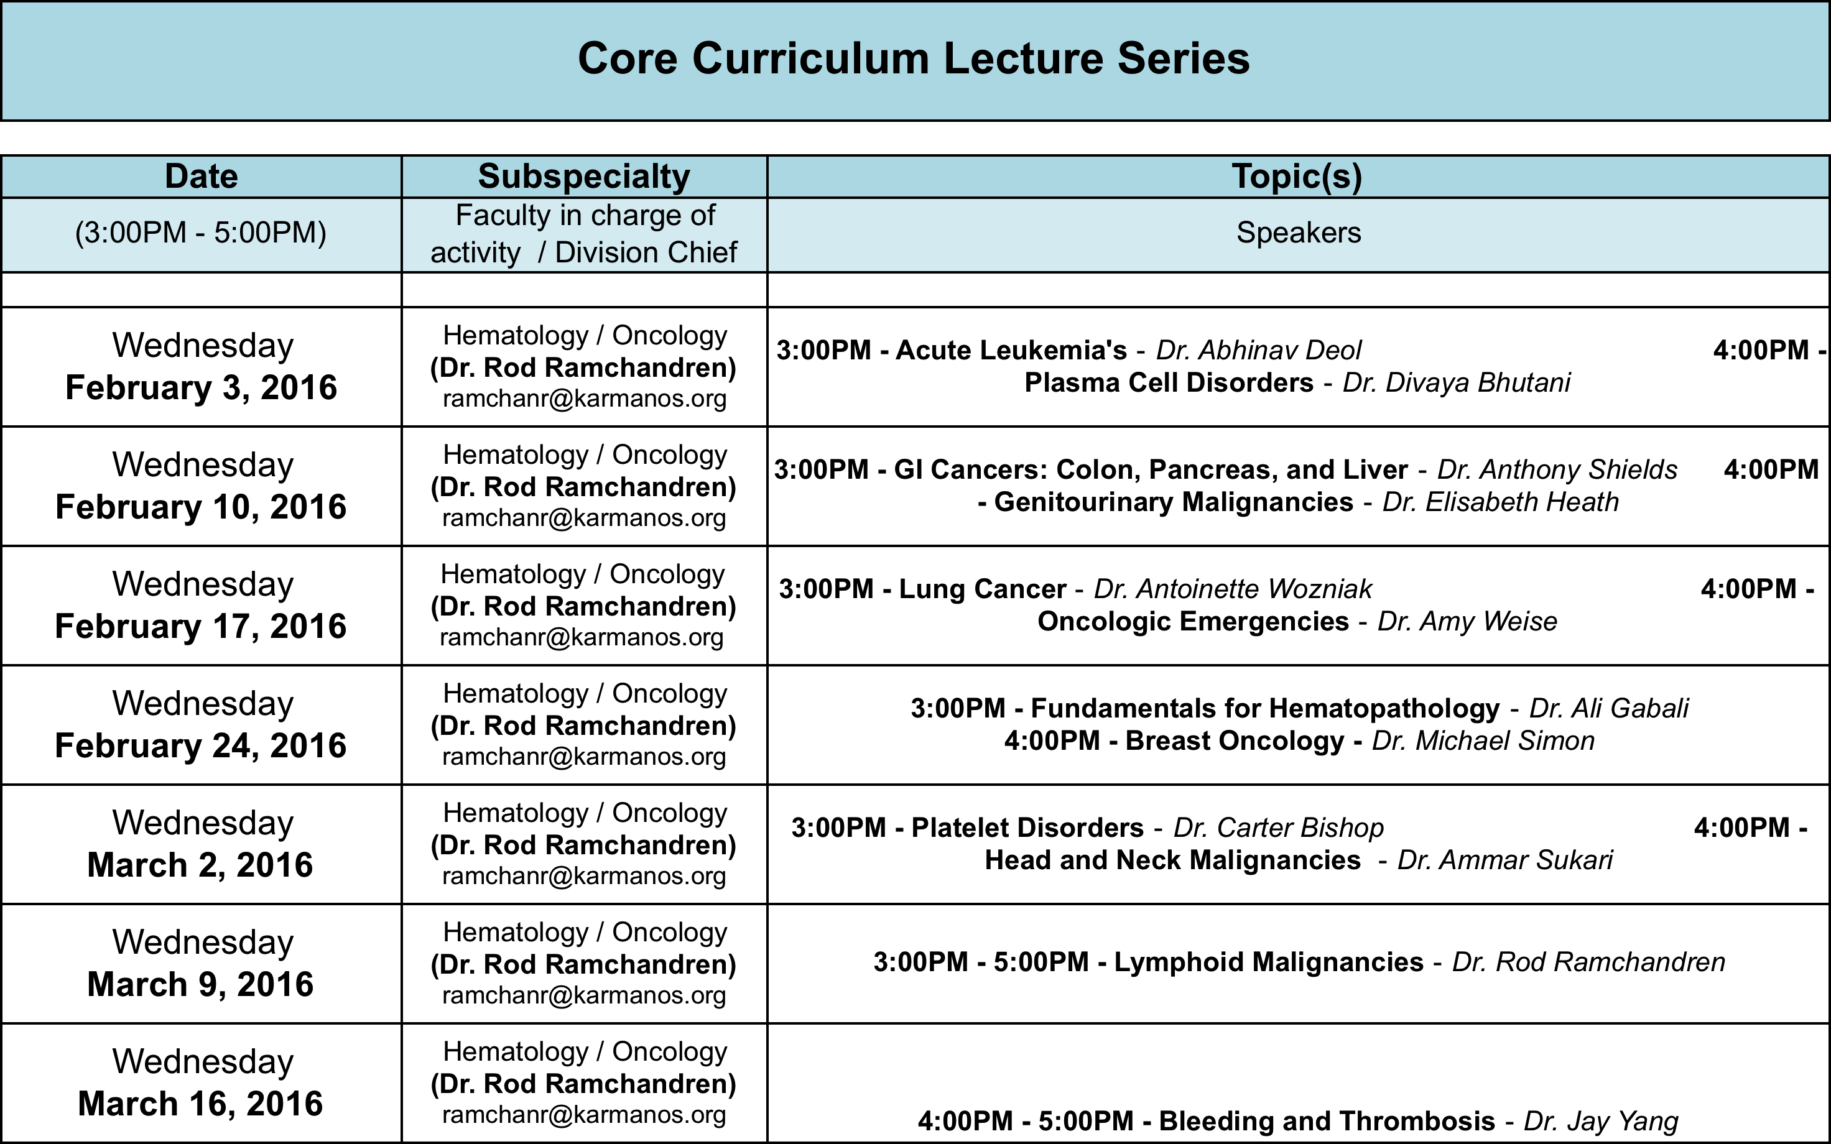

RHEUMATOLOGY
March 23
March 30

INFECTIOUS DISEASE

Infective Endocarditis Dr. Levine (April 6th 3pm)

TB Dr. Cohn (April 6th 4pm)

Infection control Dr. Dhar (April 13th, 3pm)

Skin/ Soft Tissue Infections Dr. Reyes (April 13th, 4pm)

CNS Infections Dr. Revankar (April 20, 3pm)

Antibiotics Dr. Lerner (April 20th, 4pm)

Immunocompromised hosts Dr. Chandra (April 27th, 3pm)

HIV Dr. Veltman April 27th at 4pm.

NEPHROLOGY

MAY 6 2015
- Evaluation of Kidney Function/Acid Base Disorders
Dr. Gebregeorgis
2. Fluids/ Electrolytes Dr. Imran

May 13th, 2015
1. HTN Dr. Elhassan
2. Chronic Tubulointerstitial Disease and Renal Stones
Dr. Imran

May 20th, 2015
1. Glomerular Disorders Dr. Sondheimer
- AKI Dr. Bhat

May 27th, 2015
CKD Dr. Doshi

