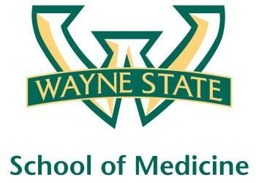
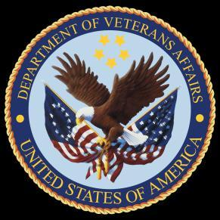
Wayne State University - VA Medical Center
Department of Internal Medicine

January 19th – February 16th 2016
12:00 pm – 1:00 pm
Except Monday 1:15 pm – 2:15 pm
Room A3102

Monday | Tuesday |  | Wednesday | Thursday | Friday
01/18 | 01/19 |  | 01/20  Orientation by CMR  (12pm- 1pm) | 01/21  Medication Reconciliation  Lecture | 01/22  NP Orientation by Megan Irwin
01/25  Radiology Lecture I  1:15 pm to 2:15 pm | 01/26  Red Team  Short Case 1 |  | 01/27  Academic Half Day  No Morning Report | 01/28  Green Team  Short Case 1 | 01/29  Blue Team  Short Case 1
02/01  Radiology Lecture II  1:15 pm to 2:15 pm | 02/02  Yellow Team  Short Case 1 |  | 02/03  Academic Half Day  No Morning Report | 02/04  Red Team  Short Case  2 | 02/05  Nephrology Lecture  Dr. Abu-Hamdan
02/08  Dr. Alward’s Lecture  1:15 pm to 2:15 pm | 02/09  Green Team  Short Case 2 |  | 02/10  Academic Half Day  No Morning Report | 02/11  Blue Team  Short Case 2 | 02/12  Palliative Lecture Dr. Stellini
02/15  M and M Morning Report  1:15 pm to 2:15 pm |  | 02/16  Yellow Team  Short Case 2

Mandatory Code Grey Simulation Schedule for Block 8

Will be held at A2 ICU Simulation Room from 1pm-2pm with Dr. Lee

Team schedule as follows

1/22/2016 Red and Green Team

2/5/2016 Blue and Yellow Team

