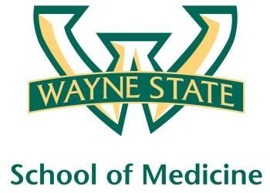
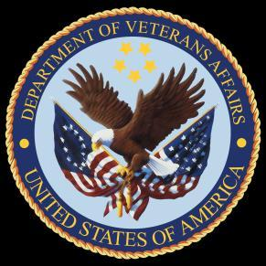
Wayne State University - VA Medical Center
Department of Internal Medicine

February 17th – March 15th 2016
12:00 pm – 1:00 pm
Except Monday 1:15 pm – 2:15 pm
Room A3102

Monday | Tuesday |  | Wednesday | Thursday | Friday
02/15 | 02/16 |  | 02/17  Orientation by CMR  (12pm- 1pm) | 02/18  Medication Reconciliation  Lecture | 02/19  NP Orientation by Megan Irwin
02/22  Radiology Lecture I  1:15 pm to 2:15 pm | 02/23  Red Team  Short Case 1 |  | 02/24  Academic Half Day  No Morning Report | 02/25  Green Team  Short Case 1 | 02/26  Blue Team  Short Case 1
02/29  Radiology Lecture II  1:15 pm to 2:15 pm | 03/01  Yellow Team  Short Case 1 |  | 03/02  Academic Half Day  No Morning Report | 03/03  Palliative Lecture Dr. Stellini | 03/04  Nephrology Lecture  Dr. Abu-Hamdan
03/07  Dr. Ramanathan Lecture  1:15 pm to 2:15 pm | 03/08  Red Team  Short Case  2 |  | 03/09  Academic Half Day  No Morning Report | 03/10  Green Team  Short Case 2 | 03/11  Blue Team  Short Case 2
03/14  M and M Morning Report  1:15 pm to 2:15 pm |  | 03/15  Yellow Team  Short Case 2

Mandatory Code Grey Simulation Schedule for Block 9

Will be held at A2 ICU Simulation Room from 1pm-2pm with Dr. Lee

Team schedule as follows

2/19/2016 Red and Green Team

3/4/2016 Blue and Yellow Team

