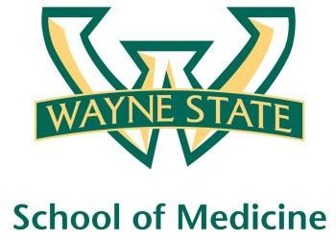
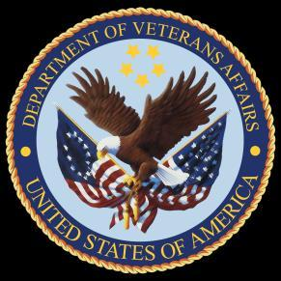
Wayne State University - VA Medical Center
Department of Internal Medicine

March 16th – April 12th 2016
12:00 pm – 1:00 pm
Except Monday 1:15 pm – 2:15 pm
Room A3102

Monday | Tuesday |  | Wednesday | Thursday | Friday
03/14 | 03/15 |  | 03/16  Orientation by CMR  (12pm- 1pm) | 03/17  Medication Reconciliation  Lecture | 03/18  NP Orientation by Megan Irwin
03/21  Radiology Lecture I  1:15 pm to 2:15 pm | 03/22  Red Team  Short Case 1 |  | 03/23  Academic Half Day  No Morning Report | 03/24  Green Team  Short Case 1 | 03/25  Nephrology Lecture  Dr. Abu-Hamdan
03/28  Blue Team  Short Case 1  1:15 pm to 2:15 pm | 03/29  Cardiology Lecture  Dr. Ramappa |  | 03/30  Academic Half Day  No Morning Report | 03/31  Yellow Team  Short Case 1 | 04/01  Red Team  Short Case 2
04/04  Radiology Lecture II  1:15 pm to 2:15 pm | 04/05  Green Team  Short Case 2 |  | 04/06  Academic Half Day  No Morning Report | 04/07  Blue Team  Short Case 2 | 04/08  Palliative Lecture Dr. Stellini
04/11  Yellow Team  Short Case 2  1:15 pm to 2:15 pm |  | 04/12  M and M Morning Report

Mandatory Code Grey Simulation Schedule for Block 10

Will be held at A2 ICU Simulation Room from 1pm-2pm with Dr. Lee

Team schedule as follows

3/18/2016 Red and Green Team

4/1/2016 Blue and Yellow Team

