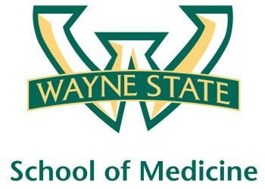
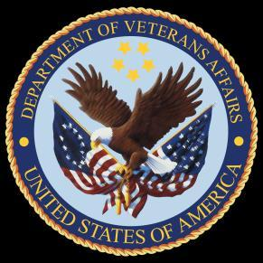
Wayne State University - VA Medical Center
Department of Internal Medicine

April 13th 2016 – May 10th
12:00 pm – 1:00 pm
Except Monday 1:15 pm – 2:15 pm
Room A3102

Monday | Tuesday |  | Wednesday | Thursday | Friday
04/11 | 04/12 |  | 04/13  Orientation by CMR  (12pm- 1pm) | 04/14  Medication Reconciliation  Lecture | 04/15  NP Orientation by Megan Irwin
04/18  Radiology Lecture I  1:15 pm to 2:15 pm | 04/19  Red Team  Short Case 1 |  | 04/20  Academic Half Day  No Morning Report | 04/21  Green Team  Short Case 1 | 04/22  Nephrology Lecture  Dr. Abu-Hamdan
04/25  Yellow Team  Short Case 1  1:15 pm to 2:15 pm | 04/26  Cardiology Lecture  Dr. Ramappa |  | 04/27  Academic Half Day  No Morning Report | 04/28  Palliative Lecture  Dr. Stellini | 04/29  Blue Team  Short Case 1
05/02  Radiology Lecture II  1:15 pm to 2:15 pm | 05/03  Red Team  Short Case 2 |  | 05/04  Academic Half Day  No Morning Report | 05/05  Yellow Team  Short Case 2 | 05/06  Blue Team  Short Case 2
05/09  Green Team  Short Case 2  1:15 pm to 2:15 pm |  | 05/10  M and M Morning Report

Mandatory Code Grey Simulation Schedule for Block 11

Will be held at A2 ICU Simulation Room from 1pm-2pm with Dr. Lee

Team schedule as follows

4/15/2016 Red and Green Team

4/29/2016 Blue and Yellow Team

