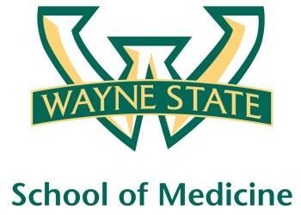
Wayne State University - VA Medical Center
Department of Internal Medicine

May 11th 2016 – June 7th
12:00 pm – 1:00 pm
Except Monday 1:15 pm – 2:15 pm
Room A3102

Monday | Tuesday |  | Wednesday | Thursday | Friday
05/09 | 05/10 |  | 05/11  Orientation by CMR  (12pm- 1pm) | 05/12  Medication Reconciliation  Lecture | 05/13  NP Orientation by Megan Irwin
05/16  Radiology Lecture  1:15 pm to 2:15 pm | 05/17  Cardiology Lecture  Dr. Ramappa |  | 05/18  Academic Half Day  No Morning Report | 05/19  Blue Team  Short Case 1 | 05/20  Nephrology Lecture  Dr. Abu-Hamdan
05/23  No morning Report  1:15 pm to 2:15 pm | 05/24  Green Team  Short Case 1 |  | 05/25  Academic Half Day  No Morning Report | 05/26  Red Team  Short Case 1 | 05/27  Palliative Lecture  Dr. Stellini
05/30  Memorial Day Holiday | 05/31  Yellow Team  Short Case 1 |  | 06/01  Academic Half Day  No Morning Report | 06/02  Red Team  Short Case 2 | 06/03  Yellow Team  Short Case 2
06/06  Green Team  Short Case 2  1:15 pm to 2:15 pm |  | 06/07  Blue Team  Short Case 2

Mandatory Code Grey Simulation Schedule for Block 12

Will be held at A2 ICU Simulation Room from 1pm-2pm with Dr. Lee

Team schedule as follows

5/12/2016 Red and Green Team

5/31/2016 Blue and Yellow Team

