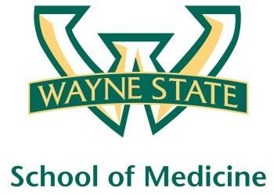
Wayne State University - VA Medical Center
Department of Internal Medicine

June 8th 2016 – June 30th
12:00 pm – 1:00 pm
Except Monday 1:15 pm – 2:15 pm
Room A3102

Monday | Tuesday | Wednesday | Thursday | Friday
06/06 | 06/07 | 06/08  Orientation by CMR  (12pm- 1pm) | 06/09  Discharge Navigator  Lecture | 06/10  NP Orientation by Megan Irwin
06/13  Radiology Lecture  1:15 pm to 2:15 pm | 06/14  Red Team  Short Case 1 | 06/15  Academic Half Day  No Morning Report | 06/16  Green Team  Short Case 1 | 06/17  Blue Team  Short Case 2
06/20  Yellow Team  Short Case 1  1:15 pm to 2:15 pm | 06/21  Cardiology Lecture by  Dr. Ramappa | 06/22  Academic Half Day  No Morning Report | 06/23  Red Team  Short Case 2 | 06/24  Green Team  Short Case 2
06/27  Blue Team  Short Case 2  1:15 pm to 2:15 pm | 06/28  Yellow Team  Short Case 2 | 06/29  Academic Half Day  No Morning Report | 06/30  Last day  No morning report | 07/01

Mandatory Code Grey Simulation Schedule for Block 13

Will be held at A2 ICU Simulation Room from 1pm-2pm with Dr. Lee

Team schedule as follows

6/10/2016 Red and Green Team

6/24/2016 Blue and Yellow Team

