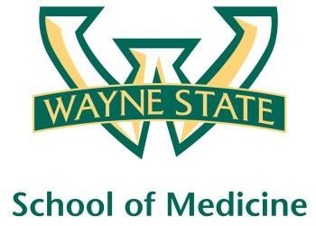
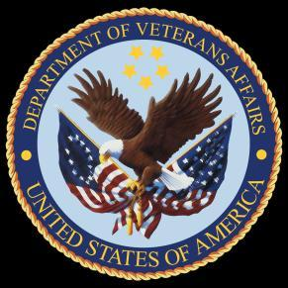
Wayne State University - VA Medical Center
Department of Internal Medicine

July 1st 2016 – July 10th
1:00 pm – 2:00 pm
Room A3102

Wednesday | Thrusday | Friday | Monday | Tuesday
 |  | 07/01  Orientation by CMR | 07/04  Federal Holiday | 07/05  Discharge Navigator  Lecture CMR
07/06  NP Orientation by Megan Irwin | 07/07  Yellow Team Short Case | 07/08  Red Team  Short Case

