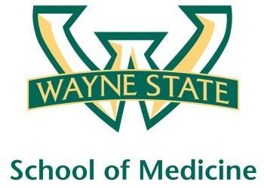
Wayne State University - VA Medical Center
Department of Internal Medicine
Weeks 2,3,4,5
1.15 PM-2.15 PM
Room A3102

Monday | Tuesday | Wednesday | Thrusday | Friday
07/11  Orientation by CMR | 07/12  NP Orientation by Megan Irwin | 07/13  Discharge Navigator Lecture CMR | 07/14  No MR | 07/15  Palliative Lecture  Dr. Stellini
07/18  Radiology Lecture | 07/19  Cardiology Lecture  Dr. Ramappa | 07/20  Code Grey  1.15-2.15 PM  Blue, Yellow | 07/21  Green Team Short Case | 07/22  Code Grey  1.15-2.15 PM  Red, Green
07/25  Red Team  Short Case | 07/26  Blue Team Short Case | 07/27  No MR | 07/28  Yellow Team Short Case | 07/29  Nephrology Lecture  Dr. Mohanty
08/01  Green Team Short Case | 08/02  Red Team  Short Case | 08/03  No MR | 08/04  Blue Team Short Case | 08/05  Yellow Team Short Case

